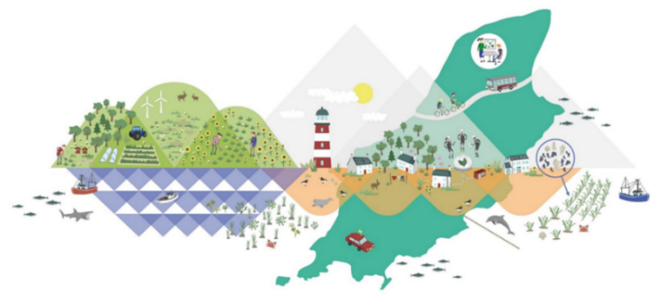

Manx Blue Carbon Working Group

Terms of Reference

Purpose
The Manx Blue Carbon Working Group (hereafter referred to as ‘the Group’) brings together interested parties from across sectors and disciplines to ensure a connected, holistic, and inclusive approach to managing blue carbon resources in the Isle of Man, to maximise carbon absorbed by and stored in Manx seas and coastal areas.
The Group’s purpose is to provide expert advice and guidance to the Manx Blue Carbon Project (hereafter referred to as ‘the project’), with ultimate responsibility for delivery of the project sitting with the Department of Environment, Food and Agriculture, and reporting to the Climate Change Transformation Board.

Management
For the duration of the Manx Blue Carbon Project, administration of the Group (meetings, record keeping, membership) will be undertaken by Department of Environment, Food, and Agriculture (DEFA) under the Manx Blue Carbon Project team (hereafter referred to as ‘the project team’). DEFA Climate Change and DEFA Ecosystem Policy Teams, as funders and hosts of the project respectively, will be involved in relation to project governance (see Annex A for project reporting and governance structure).
This arrangement and these Terms of Reference will be reviewed annually, with any amendments agreed by consensus from all Members. Members may propose amendments to these Terms of Reference at any time, for consideration and decision at the next available meeting of the Group.

Membership and Observers
In addition to those responsible for project governance, Members will comprise of parties with an interest or expertise in blue carbon and holistic marine management in the Isle of Man’s territorial sea. See Annex B for a current list of Members.
Membership will be considered from interested parties with expertise in the following areas:
- Business, the blue economy, and marine innovation
- Climate change
- Fisheries and fisheries management
- Marine biodiversity and nature conservation
- Science and research
- Spatial planning, seabed and marine infrastructure management
A maximum of three seats will be available for each sector; organisations may request more than one seat, if available. For sectors with more than three interested parties, the Group will review membership annually (or if a Member leaves) and may rotate between organisations each year; current Members from the sector under review will be exempt from voting. In the event of more than three suitable membership requests in any one sector, additional seats may be made available at the discretion of the Group, giving consideration to the implications of any additional seats on the balance of representation.
Where a Member does not attend two meetings in a row or submit apologies a week in advance, the Group may reallocate membership to another organisation from that sector.
Interested parties will apply for membership through the project team, detailing their interest in and relevance to blue carbon in the Isle of Man, and the sector(s) of expertise in which they operate. Suitable applications will be submitted to the Group for decision at the next available meeting.
Memberships will be decided by Group majority; in the event of a split vote, the decision will be taken by the DEFA Minister or a designated representative.
Observer status may be granted where there are more than three interested parties in a particular sector, or where the Group does not deem membership appropriate. All Members and Observers will receive relevant Group correspondence (including meeting agendas and notes) and can submit items for meeting agendas, but may not attend meetings. Members and Observers may resign, and Members may request to become Observers, at any time by advising the project team.

Meetings
The Group will meet quarterly, convened and chaired by the project team; additional meetings may be convened as necessary at the request of Members. The quorum for any meeting will be half of all current Members, to include one Member of the project team and at least one other Member representing project governance.
Members can determine who will attend from their organisation, which can change between meetings depending on the needs of both the organisation and the Group. Additional seats may be requested or non-Members invited for specific meetings, should the need arise; the project team will consider these requests on a case-by-case basis.
Members and Observers can submit items for the meeting agenda to the project team up to two weeks before the meeting; the agenda will be shared one week before the meeting.
Group meetings will be treated as confidential. Meeting notes will be shared with Group members for approval and any commercially or otherwise sensitive information can be anonymised or, where necessary, redacted. Once approved for publication by the Group, meeting notes will be made publicly available on the NetZero Blue Carbon website to ensure transparency.

Conflicts of Interest
If a Member has any conflict of interest in a matter being discussed by the Group, they must disclose the interest prior to the meeting if it is a listed agenda item, or as soon as the matter arises (e.g. if it arises in a meeting under Any Other Business or from discussion of other matters, or in email correspondence).

Any Member with a conflict of interest will excuse themselves from the meeting (or ask to be removed from emails) whilst the matter is being discussed, and will not attempt to influence any other Members on the matter before, during, or after discussions take place.

Outputs
Any outputs from or on behalf of the group must be agreed by consensus of Members, and approved by the DEFA Minister or a designated representative. All outputs must be in line with existing (and emerging) Government policy and legislation. Between group meetings, approval can be obtained via email, clearly stating reasonable deadlines for any objections to be raised.

Version control
Version | Change/purpose | Author, date | Approved
2.2 | - Section 3 ‘Memberships and Observers’: updated to allow Group to make additional seats available if appropriate.  - Section 5 ‘Conflicts of Interest’ added; move ‘Outputs’ to section 6.  - Reporting Structure updated to reflect change in Climate Change Team.  - Members list updated to add Deloitte.  - Version control table added. | Jacqui Keenan, Apr 2023 | 19 Apr 2023
2.1 | Removed Chatham House Rule; added notes on confidentiality. | Jacqui Keenan, Sep 2022 | 10 Jan 2023
2.0 | Amended following Group review, including clarification of decision making, membership applications, process for reviewing Terms and membership, and list of members/sectors. | Jacqui Keenan, Sep 2022
1.0 | Circulated to Working Group for review. | Jacqui Keenan, Aug 2022
0.1 | Draft versions reviewed internally at DEFA. | Jacqui Keenan, Jul 2022

Annex A: Manx Blue Carbon Project Reporting and Governance

Current as of April 2023
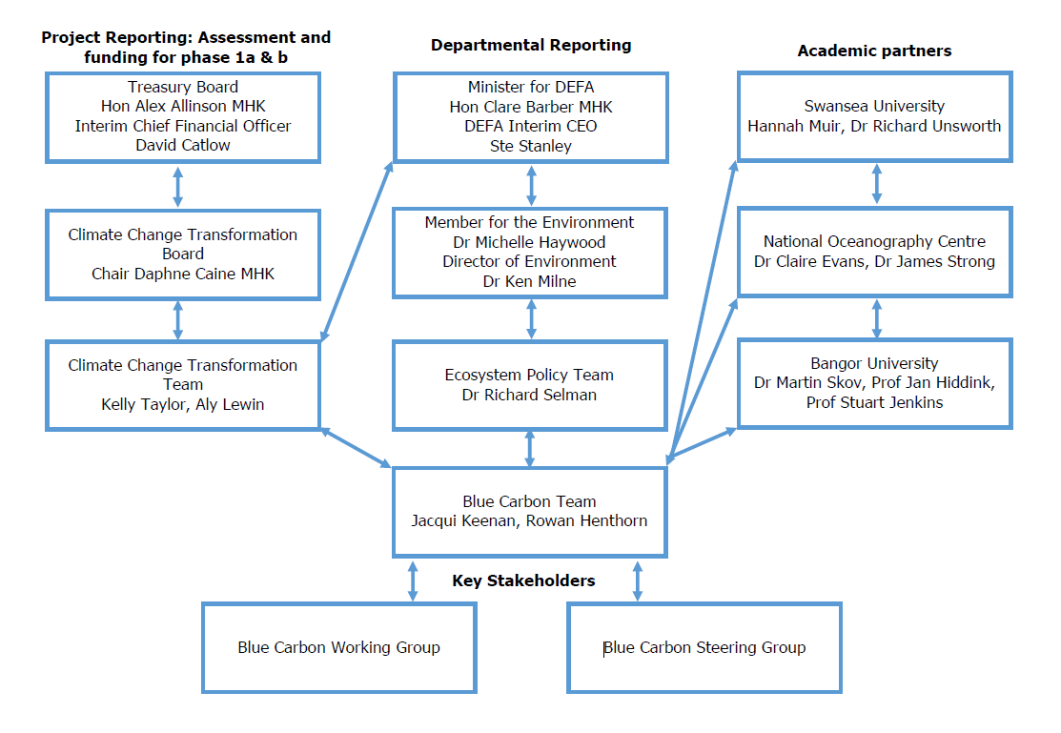

Annex B: Current Working Group Members and Sectors

- Business, the blue economy, and marine innovation
- KPMG
- Department for Enterprise
- Deloitte
- Climate change
- DEFA Climate Change Team
- Fisheries and fisheries management
- DEFA Fisheries Team
- Manx Fish Producers’ Organisation
- Marine biodiversity and nature conservation
- Manx Wildlife Trust
- Science and research
- National Oceanography Centre
- Swansea University
- Bangor University
- Spatial planning, seabed and marine infrastructure management
- Department of Infrastructure
- Governance
- DEFA Blue Carbon Team
- DEFA Ecosystem Policy Team

